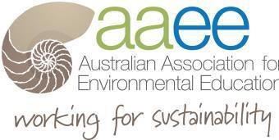AAEE Executive and the Award Recognition Committee invite nominations from Chapters for the

12thAnnual Award for

Outstanding Contribution

to

Environmental Education in Australia.

The Award is presented to an AAEE Member who has made an exemplary contribution to the field of environmental education. Prior Chapter nominations can be entered again.

Name of Nominee Contact Address

Contact
Phone/email
Nominated by Chapter
Contact Phone/email
Signature

SEND CHAPTER NOMINATION TO:
AAEE EfS 2019 AWARD
sustainability.learning.centre@education.tas.gov.au
NOMINATIONS Close: Sep 16th 2019

Previous winners
www.aaee.org.au

AAEE Recognition Judging Panel
Composed of a representative from each AAEE Chapter and current AAEE President.

Timeframe

- Submissions close
Sep 16th 2019
- Submissions reviewed by the AAEE Recognition Panel.
- Award Winner notified by email by late Sept
- Award presented at the AAEE National AGM

The Submission
Please attach to this Nomination Form a submission that details relevant information relating to the nominee (limit 5 pages)

Please supply name of a technical referee.

The judging panel will make a determination on the winner based on the submission that best addresses the following criteria:

- Current member of AAEE - 1 nominee/Chapter
- Made a substantial contribution to EE/EfS
- Desirable but not necessary National contribution’ and/or ‘national leadership’
- Demonstrated an ongoing commitment to EE/EfS.
- Exhibited leadership that has influenced others
- Led by example and walked the sustainability talk

