Australian Sustainable Schools Alliance

Sustainable Schools Teacher of the Year

Recognition Awards 2020

Booklet

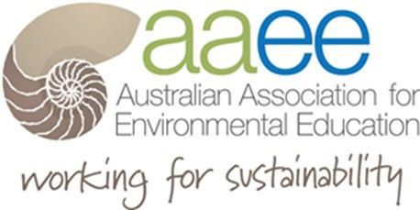

Australian Sustainable Schools Alliance
Sustainable Schools Teacher of the Year Recognition Award – 2020

Celebrating the teacher’s that best demonstrate leadership in sustainability across Australia.

The Australian Sustainable Schools Alliance - Teacher of the Year Recognition Award recognize the nominated teachers from each Australian State and Territory Sustainable Schools program.

This is an opportunity to highlight the amazing contribution teachers make to our sustainability journey in Australia. Each Sustainable School program was asked to put forward a nominee who will be recognised as an outstanding Sustainable Schools Teacher from their State or Territory.

AuSSA Teacher Award recognition criteria.

• demonstrates sustainability leadership

• leading sustainability activities in schools including addressing sustainability as a cross-
curricula priority in the Australian Curriculum

• mentoring student leadership in sustainability

• leading engagement with the school and broader community

• leading campus innovations with best practice methods & standards on school grounds

Chairperson

Sue Martin

President

Dr Jennifer Pearson
AUSTRALIAN CAPITAL TERRITORY

Jointly nominated by AAEE ACT and ACT Smart Schools Program

Tarun Whan - Caroline Chisholm School

Tarun Whan, known as Mr Taz, is a Science and Digital Technology teacher who arrived at Caroline Chisholm School in 2016. The Sustainability Squad consists of 12 students that strive to create positive change for sustainability in our school community. Under his leadership they won Actsmart Schools’ Student Leadership Team Award in 2019. The list of Tarun’s and the Sustainability Squad’s achievements include:

- installation of an electricity monitoring system measuring consumption in each building, using the data to develop strategies to reduce consumption;

- organised waste audits leading to the introduction of general recycling, soft plastics collection and container deposit recycling;

- establishment of an E-waste community drop-off cen- tre in partnership with WV Technologies;

- initiated Sustainability Ignite, a timetabled sustainabil- ity lesson each fortnight across the school and peer mentoring sustainability lessons in the Junior and Pre- school campus delivered by Sustainability Squad stu- dents.

As a consequence of Tarun and the Squad communicating data and research results, sustainability issues are now viewed with importance and are an agenda item at school board and P&C council meetings.

Tarun has engaged students to research sustainability issues around the school, develop strategies for improve- ment and seek funding and resources to enact solutions. In the classroom, Tarun has lead by example, embedding
sustainability learning outcomes within both his Science and Digital Technology classes, and has encouraged teachers and curriculum coordinators to incorporate sustainability into formal assignments across the curriculum. Under Ta- run’s guidance, the Sustainability Squad has developed a website to help spread messages promoting sustainability and it is expected that this will be linked to the school website, newsletters and social media. This will extend their messages to families and the wider community.

Staff have been significantly shifted toward sustainable behaviours and approaches through best-practice waste management (organics, soft-plastic, general recycling, paper and general waste) systems in staff rooms. During the previous winter, the energy monitoring system that the Squad manages, was used to highlight to staff when heaters had been left on overnight and rewards were given to the most sustainable staffroom, creating some friendly competition to drive sustainable behaviour. A number of staff and students have now commented to Squad members how they have improved their home waste management systems due directly to the learning that the Squad has provided at Caroline Chisholm School. Sustainability is now an agenda item at School Board meetings and P&C Council.

Additionally, Tarun’s Sustainability Squad identified that hydraulic door closers fitted to strategic locations around the school could substantially increase the energy efficiency of our school. The school has committed funding for 22 units to be installed across both the Junior and Senior Campuses based on this data. The impact of the inaugural school community E-Waste muster is potentially huge, both as a financial bonus for the school, but more importantly in educating and value-adding to the school community. All of these are significant projects, and it is likely that without Tarun’s commitment to educating staff and students about sustainability issues they were unlikely to be initiated, let alone succeed.

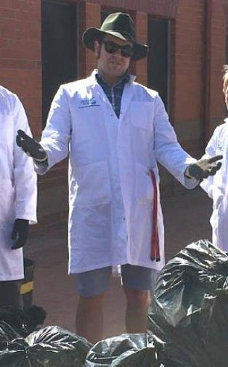
Tarun has made an enormous impact on the behavioural and physical structures at Caroline Chisholm School, though his most significant achievement is his ability to capture the imagination of students and inspire them to make a differ- ence.

NEW SOUTH WALES

Nominated by AAEE NSW
managing Sustainable
Schools NSW program

David Giblin, Chifley College, Bidwill Campus

David Giblin is Science and Agriculture at Chifley College, Bidwill Campus since 2007. During this time, he has embedded Agriculture as a key subject at our school with up to a quarter of our students participating in the subject. He has taken what was a rundown facility and effectively rebuilt the resource so that it is a model of, not only Agriculture teaching, but the teaching of sustainability. In 2016 the school farm was nominated with the Department of Education, Futures Directorate, as a classroom of the future due to the strong focus on sustainability.

David has established many partnerships with local businesses that include green waste recycling from local garden maintenance contractors and from our Local Woolworths store and the recycling of coffee husks and hessian bags from a local coffee roaster. In addition, David has been an active member of the Agriculture Teachers network; Marine Teacher Association; and the Local Schools Sustainability network where he lends his expertise to other schools as to how sustainability can be taught and presented. He has been instrumental in establishing the Primary Schools fruit and vegetable competition (an extension of the school’s Agricultural competition) at Penrith Show, which will be run for the first time at this year’s show in August.

The farm facility is frequently visited by other schools including students enrolled in Special Education Units within the Chifley College campuses. In this way he has extended the teaching of sustainability to a wider range of students. This facility continues to support student learning and provides a wildlife refuge within the school grounds.

In addition, David, with the involvement of our students, has established numerous gardens within the school grounds. These gardens include the planting of native trees and shrubs that support our native and European bee populations; succulent, rainforest and bromeliad gardens that support the teaching of plant adaptations; and plantings that enhance the local school environment. Our gardens have won local gardening awards in Schools; General; and Sustainability; categories in the Blacktown City Garden Competitions in 2016 and 2017. David’s chrysanthemum project, which has been running for over a decade, allows students to be directly involved in grow- ing a “crop” over an annual cycle.

This project culminates each year with the harvest of flowers, which are then sold throughout the school and community for Mother’s Day. Students get to experience, not only the

growing of plants but also creating a saleable product at the end of the cycle.

Student participation in the recycling of green waste has enhanced their understanding of recycling and the need to redirect waste products away from landfill. David established a partnership with TAFE Outreach for the delivery of Certificate II in Horticulture from 2012 to 1217 and is currently in discussions with TAFE for its reestablishment in 2020. This partner- ship has brought a range of individuals and organisations together in order to share their expertise in sustainable practice.

David has had a focus on the productivity of soils and worked towards improving soil fertility on our farm site. David has further enhanced his teaching practice by developing a Project Based Learning activity on soil productivity, where students will be in the “field” collecting first hand data and developing a greater understanding of this valuable resource. David has recently taken over the running of the school bee- hives. The hives were installed to promote pollination but we have recently extended this to the extraction of honey. David has had to expand his skills to include beekeeping and has connected with the Parramatta and Nepean Beekeepers Associations to build on his skill set. He has also established a colony of native bees and is expanding his skills to include a range of native bee species.

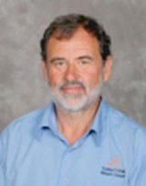
The inclusion of aquaponics and hydroponics has required David to develop a range of skills in the establishment and maintenance of these systems. He has guided our students through the construction phase and is using his expanded knowledge of water testing as part of the unit’s ongoing operation. Under David’s guidance, students have now produced their own YouTube videos that explain the system they have created. David has also been involved in the establishment of mid-story planting as a way of restoring our Cumberland Woodland. He has sourced local native plants from several sources and to date planted around 400 native shrubs and small trees that will support bee and local bird activity.

QUEENSLAND

Nominated by Sustainable Schools
Network Queensland

Erin Merrin

As the Chairperson of the Sustainable Schools Network Limited, Erin Merrin has made a significant contribution to Education for Sustainability. Erin is a founding member of the SSN and has been a part of the development of this organisation. As both an AAEE member and the SSN Board Erin is demonstrating her ongoing passion and commitment for all things EfS.
An example of Erin’s significant contribution to EfS was her recent presentation to Minister Enoch’s and Minister Grace’s policy advisors. Erin acted as an advocate for many QLD organisations and did so in a professional and dedicated manner. Her School was right behind her allowing her the day off to participate in this process, which demonstrates how she has engaged her employer in the important work she does.

As well as being the Chairperson of the SSN, Erin has also been the Social Media Coordinator and Networking Night Coordinator. At times I wonder when Erin sleeps as she dedicates so much of her time leading EfS projects. Erin is driven, knowledgeable and is doing what it takes to ensure both students and the wider community take EfS seriously.

Erin Merrin is the Head of Humanities (Years 10-12) at a Gold Coast private school (All Saints Anglican School) and is also unofficially titled the School’s Sustainability Coordinator. Some years ago, Erin was given a term to investigate the sustainability of the School and to recommend improvement strategies. Erin made a number of recommendations and was able to report on the significant wetlands project that ensures the school only uses the equivalent of one flush of a toilet per day per person of water to manage the entire ELC-12 campus.

As an EfS advocate within her school, Erin facilitates the environment and social justice committee that consists of Year 12 student leaders that deliver meaningful projects each year. By supporting these students Erin is creating the next generation of community leaders and responsible citizens. Erin also has the job of helping all staff work towards sustainability (her inbox is full of questions) and running the schools Green Week activities or Green day (alternates each year). Erin is regularly called upon to represent that school in speaking engagements as a sustainability and geography specialist and also to provide input into the planning of the school programs and campus development.

Erin has a reputation amongst her peers and the school leadership as a sustainability champion. Her school, at her request has agreed to host a large sustainability event (2021 Sustainability Symposium).

Beyond her role on the SSN as Chairperson and her role within her school, Erin is walking the walk in her personal life. Erin runs a Facebook page called the ‘Low-Carbon Queen’ where she shares ideas about how to live a sustainable life. Erin uses this Facebook page to support many others in an effort to raise the profile and visibility of EfS. Erin has her own vege garden, is an enthusiastic recycler and is a creative cook (making great cordials and foods from the excess in her fridge/cupboard). Erin lives close to work and has engaged her only daughter in youth activities that support sustainability. She works hard to lead by example and ensure that what she teaches is what she does.

As an AAEE member and SSN Chairperson, Erin is familiar with the UN SDGs. Erin creates lesson plans to ensure her students are learning about the SDGs and speaks publicly where possible also. It is Erin’s intent to raise awareness about the SDGs, so that as a community we can all take action on these important global goals. It is impossible to align Erin’s work with any one goal as what she does relates to all 17 goals
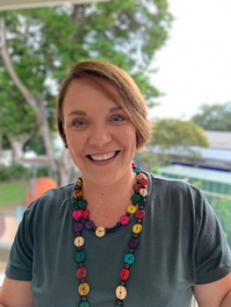

SOUTH AUSTRALIA

Nominated by the Green
Adelaide Education Team

Mary-Alice Williams, Allenby Gardens Primary School.
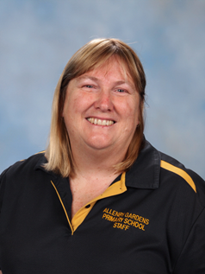

Mary-Alice, the Reception teacher, provides inspiration to other teachers in the way she uses the school garden as an adaptable learning space. She plans garden activities to align with curriculum outcomes that meet student learning needs. Other teachers have adopted this approach, viewing the garden as a place where student learning and wellbeing can be fulfilled.

Cross-curriculum priorities, in particular, Aboriginal and Torres Strait Islander histories and cultures and Sustainability are a focus. Garden activities that link to the curriculum include exploring, digging and planting. The students discuss the learning intentions so that expectations of the tasks are clear.

As the initial driver of the garden as a learning space, Mary-Alice hosted a workshop with pre-service teachers and a session called The Open Classroom: excellence matters for early careers teachers, in which 16 newly graduated teachers experienced students engaging in their garden learning activities.
Many of the Student Services Officers (SSOs) work with Mary-Alice and the students in the garden. This hands-on interaction has built on the skills and knowledge of the SSOs to engage with the garden as a learning environment. Mary-Alice has driven the staff and parent working group, and the student action group at the school for many years.
Quote from MA - I plan activities in and focus on the natural environment to cater for the wide range of individual needs in my class. For example, sorting natural objects by 2s, observing the annual cycles and seasons (the apricots are now ripening), digging up the garlic. Another activity was the drawing of garden maps (abstract) and then constructing them in foil containers using natural and other objects (concrete).

The children and I set a goal each week to also explore at home. One of our science goals was to explore the connection between grapes from the garden and sultanas. The learning intentions come directly from the Australian Curriculum. We use and explain the direct language with the children. The learning intentions are based on what the children need to know, whilst incorporating what they have identified as things they like to do in the garden e.g. exploring, digging and planting. The challenge has been to change my teaching to how children learn today. I had to adapt my teaching and delivery to match the needs of both children and parents. With science I had to change my head set from what we used to do i.e. demonstrate and tell to challenging children to ask questions and explore answers.
Mary-Alice mentors early career teachers from around the state. Case studies about the school’s initiatives can be found here.
h tt p s://l an d scap e. sa. go v.a u /fi l es/ sh ar ed a ss ets/
ad el ai d e_an d _ mt_l ofty _ra n ge s/n rm _ed u cation /al l en b y - gard en s -b ri n gi ng -th e-au stra l i an -cu rri cu l u m -to-l i fe -gen .p d f

h tt p s://l an d scap e. sa. go v.a u /fi l es/ sh ar ed a ss ets/
ad el ai d e_an d _ mt_l ofty _ra n ge s/n rm _ed u cation /
case _stu d i e s/al l en b y -gard en s-efs -l ear n i n g -sto ry -gen .p d f

Sandy Warner, Port Elliot Primary School.

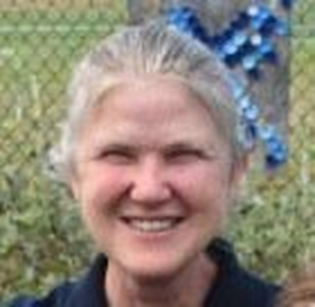

Sandy takes a leadership role with sustainability at Port Elliot Primary School. She has coordinated Student Speak Summits at the school for last two years, focussing on sustainability issues including climate change and biodiversity, and has included two other schools in the event each year. A big part of this is mentoring student leadership, and them having a focus on sustainability, to run the summits.

Sandy has led a drive to include sustainability activities in the school across subject areas integrating sustainability as a cross-curricula priority. She worked with other staff to plan and implement planting days with students to revegetate local coastal areas working with the local Coast Protection Officer and Friends of Group.

Sandy is leading engagement between the school and

broader community through planning the coastal revegetation events with the Friends of Group and the Coastal Officer. She has also involved Local Government, industry and the local Federal member of Parliament in presenting at, and listening to student presentations at the Student Speak Days.

Sandy is leading campus innovations with best practice methods & standards on school grounds by working with other teachers to form a staff sustainability group which was responsible for getting a grant to plant out school grounds with local native plant species which various classes were responsible for and were used as a learning resource (with Ron Blacker (teacher)). The group also attained a grant to progress the Student Speak Days and the coastal plantings. By having a staff sustainability group, sustainability is embedded in learning for the long term and not the responsibility of one teacher.

Laura Carrington, Sustainability Coordinator Golden Grove High School.
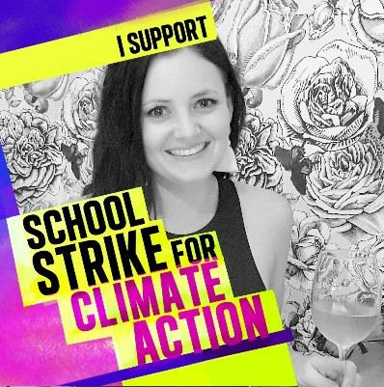

Golden Grove High School has a well-established Environ- mental Action Team (EAT), led by the school’s Sustainability Coordinator, Laura Carrington. EAT includes a dedicated team of staff who volunteer their time to engage the school com- munity in a range of sustainability-related projects, students from Student Voice who are passionate about the environ- ment and members of outside agencies such as KESAB and Green Adelaide. The school’s vision is to have an educated and informed school community that recognises that they have a moral responsibility (personally and collectively) for the environment that motivates action through knowledge and respect for the environment around us.

Laura coordinates the EAT and is the driver of a number of sustainability initiatives throughout the school. Her passion and enthusiasm for all things sustainability, in particular waste/resource recovery, is contagious and she has the ability to inspire others and encourage them to come along on the journey. Not only is Laura a passionate high school educator, she is also passionate about educating the wider community. She established and runs the Refuse, Reduce, Reuse, Recycle in Adelaide Facebook page, and is an active member of her local community.

Some of the key achievements of the EAT over the last couple of years include:
- Formation of the Environmental Management Unit (EMU) which is a passionate group of students who meet once a week to raise concerns and offer student-led initiatives in the field of sustainability. Laura initiated and runs this group.
- Inclusion of sustainability topics and assessments through various subject areas.
- Bin audits and implementation of recommendations.
- Sustainability presentations for the school community.
- Planting a range of herbs for use in the Home Economics kitchen and purchased a compost tumbler to be actively used in the school to re-use our green waste in a mean- ingful and sustainable way.
- Significant reduction in paper usage through a variety of strategies.
- Establishment of Year 8 HASS Immersion Day twice a year at nearby Cobbler Creek Recreation Park to engage students in the wider community by giving them the opportunity to participate in conservation projects and learn about the cultural significance of the site.
- Raising approximately $1500 each year from recycling plastic bottles and cans – this was a whole school effort.
- Securing funding for the installation of 350 solar panels across the whole school, plus extensive update of LED lighting around the school.
- Soft plastics waste disposal successfully implemented in staff room to reduce soft plastics going to landfill.
- Sports Day moving towards being a 'sustainable event', with less waste going to landfill and students and staff encouraged to wear clothing and accessories in house colours which have been borrowed, op shopped, worn year after year and/or passed on to younger siblings.

School website Environmental Action Team page:
Environmental Action Team - Golden Grove High School (goldengrovehs.sa.edu.au)

Video Case Study; Golden Grove High School Embedding Sustainability: Golden Grove High School embedding sustainability - YouTube

Video; An Ecological Approach – using the Site Environment Management Plan to engage staff, students and parents in sustainable practices:
Golden Grove High School An Ecological Approach - YouTube
TASMANIA
WESTERN AUSTRALIA

Nominated by AAEE Tasmania Chapter

Jenny Dudgeon, Sustainability Learning Centre Hobart College

Jenny has had a long career in teaching – she started teaching in 1980 and began an Australian Sustainable Schools job in the mid-2000s. Jenny manages the Sustainability Learning Centre, incorporating Aboriginal education, and Jenny conducts sustainability activities as well, daily. Jenny co-ordinates the Kids4Kids conference every year since 2009, State-wide, with 1000 school participants every year. This involves the co-ordination of many teachers, student leaders and adult mentors.
Jenny is pivotal in AAEE Tas, with the role of president for the past 10 years until 2020. Jenny has had and continues to have roles on AAEE national helping to develop national Sustainability cross-curriculum priorities and assisting in the Early Childhood education sector.
Jenny has a role in National Science Week every year in Tas, usually Festival of Bright Ideas. Jenny is part of the Science Teachers Association of Tasmania, Tas Nature Play Network, Early Childhood Education Tasmania.
For the 2016 AAEE national conference in Hobart and CONASTA in 2018, Jenny held a pivotal role. She Is a great networker. Jenny assists Hobart College to make changes to their recycling infrastructure and environmental practices, and mentors’ other teachers and schools in ‘green’ practices e.g. Howrah Primary School.
Through AAEE Tas, she invites the community to participate in activities such as repair café, nature play, citizen science BioBlitz and promotes Climate Stories.
Nominated by AAEE WA
and Sustainable Schools WA

Elaine Lewis, Coolbinia Primary School

Dr Elaine Lewis is the Cross Curriculum Leader at an independent public school, Perth, Western Australia. In this role Elaine works collaboratively with school staff to embed the Sustainability Cross Curriculum Priority of the Australian Curriculum across all Learning Areas. She has worked as a teacher K-Year 7, for many years and in 2008 was awarded the de Laeter Medal for “Outstanding Contribution to Science Teaching”. Her research interests focus on Education for Sustainability (EfS), with particular interest in the Sustainable Schools WA initiative.

Elaine completed her doctoral research in this area, con- ducting a longitudinal study of the impact of EfS at a primary school. In 2012 Elaine was presented with the national “Educator of the Year” award by the Australian Association for Environmental Education. Then in 2015 and 2017, the United Nations Association of Australia acknowledged Elaine’s work in school carbon emission reduction action by presentation of the “World Environment Day” Sustainability Awards (Schools category).

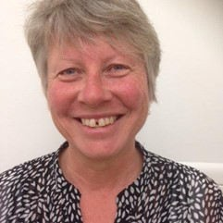
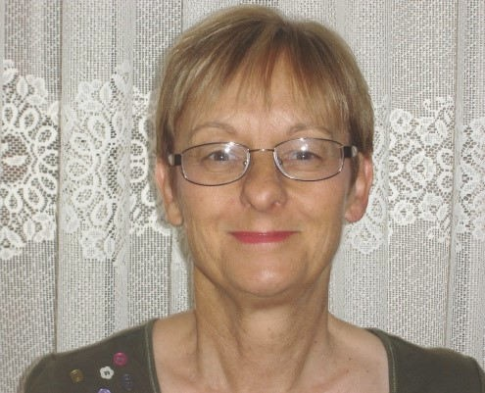
Dr Lewis serves on the management committee of the Australian Association for Environmental Education - WA Chapter and is the Convenor of the Education Committee of the One World Centre Inc (WA). In these roles Elaine is involved in many school and community-based EfS initiatives. She also has experience as a unit coordinator and lecturer in environmental and teacher education at Murdoch University and Edith Cowan University Australia.

VICTORIA

Nominated by VAEE partner organisation ResourceSmart Schools Victoria

Loretta Leary, Mount Waverley Primary School

Loretta has led the sustainability program at her school for 19 years. This in itself is worthy of a medal. Loretta has put an impressive range of achievements to her name, leading up to some fabulous new outcomes in 2019 for the environment and the greater school community.

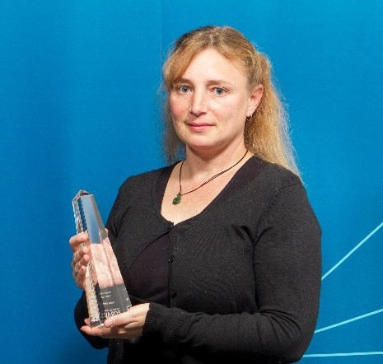
Loretta provided great leadership and mentorship in the EfS Community of Practice (eg contribution to the professional development of others and to the activities of professional associations)

Since becoming Principal of Mount Waverley Primary School I have observed our Environment leader, Loretta Leary both initiate new ideas with regards to environmental education and continue to improve existing programs she had already implemented. Each term Loretta delivers a one hour professional learning session for teachers which are informative, engaging and continue to lead teachers in their own under- standing of the importance of environmental education.

Loretta’s leadership with the community has led to the school having a comprehensive recycling program including paper/cardboard, cans, bottles, plastics, batteries, mobile phones, ink cartridges, food scraps, water and light bulbs. The food scraps are used to feed an extensive worm farm and water is recycled through both the use of a large number of water tanks and tubs under drinking taps which are then spread on our gardens. Each year level is responsible for a different element of recycling.

Target Tuesday has led to a huge reduction in our landfill waste and most importantly, our students are passionate about keeping our yard free from rubbish. Rubbish free lunches also contribute towards a reduction of rubbish in our yard. Loretta leads the school with a number of key educational days including: Tree Planting Day, Clean UP Australia Day and Green Day.

Loretta has continued to expand our biodiversity program with the introduction of a butterfly garden and she continues to educate the school community on the importance of planting indigenous plants to the area. The permaculture Garden and junior school gardens are predominantly cared for by the student environment teams which Loretta leads with support from other teachers.

Kids Teaching Kids is a significant event on our calendar, again led by Loretta, and each year we receive positive feed- back from schools across Melbourne who visit our school and take part in environmental learning tasks with our students. In a broader sense, Loretta has a major role on our Community Engagement Team, The Buildings and Grounds committee and liaising with our groundsman.

I recommend Loretta Leary in the strongest possible terms due to the enormous positive influence she has had on the Mount Waverley community in regards to environmental education.

