Pre-Service Teaching Scholarship | 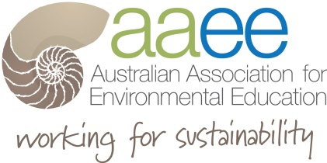

This is an application for Teacher Education students enrolled in early childhood, primary or secondary courses, to apply for an Arthur Thyne Reid Foundation Teacher Education Student Scholarship Package.

This package provides students with 3 years membership of AAEE. There are up to 10 packages available in each of the eight Chapters of AAEE. These include ACT, NSW, VIC, TAS, QLD, SA, NT and WA. The package will also include access to funding to attend a local or national event over the life of the 3 year membership.

Applicants Information
Full Name: |  |  | Date:
 | Last | First

Address: |  | Postcode

Phone: |  | Email
Signature

Institution Staff Contact Information

Full Name: |  |  | Date:
 | Last | First

Address: |  | Postcode

Phone: |  | Email
Signature

Submission

Please complete the submission criteria below that details relevant information relating to the applicant. Each criteria response no more than 250 words and evidence and verifiable examples.

The submission is to be supported by evidence of enrollment in the respective teaching education degree from that institution. Please attach to this submission.

The judging panel’s selection will be based on the submission that addresses the following criteria.

- Outline an environmental issue that you are passionate about? (250 words)

- What is a particular aspect of education for sustainability that you would like to know more about? (250 words)
- What support do you need to help your development of your understanding of how to teach education for sustainability? (250 words)

SEND NOMINATION TO: Attention: AAEE ATRF admin@aaee.org.au

Attach file using your names for file name e.g. AAEEATRF_SLogan

NOMINATIONS Close: when all positions allocated

AAEE Website www.aaee.org.au/projects/grants

- Submissions reviewed by the AAEE Panel
- Applicants notified by email as they are assessed
- Applicants given membership and appropriate Chapter notified for mentoring.

