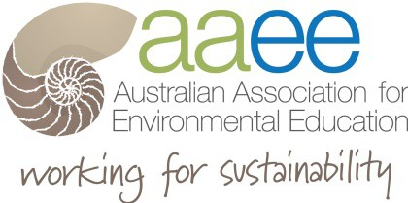
World Environment
Day Grant
2022

There will be two grants provided for the annual AAEE World Environment Day Grant. AAEE members can apply for up to $500 to produce a short 3 – 5 minute video of their integrated sustainability practices with a link to the World Environment Day theme of Ecosystem Restoration
We also require up to two pages to outline your project or lesson plan sequence or case study for distribution on the Getting Started in Sustainability in Schools website. This gives an opportunity for others to implement into their work, check out the site for ideas at www.sustainabilityinschools.edu.au

Lead Teacher Information

Full Name: | _________________________________________ | ______________________________ | Date:
 | Last | First

Address: Postcode

Phone: Email

Signature

Submission

Please complete the three submission criteria below to detail relevant information for the application. Each criteria response is to be no more than 300 words and include evidence and verifiable examples.

The submission is to be also supported by two letters of no more than 250 words each endorsing the applicant’s activity in their community or a technical referee. Please attach these letters to the submission.

The judging panel’s selection will be based on the applicant’s responses to the following three submission criteria.

1. Outline what your early childhood service or school has implemented and any links to external communities (300 words).

2. Explain how the initiatives are linked to the ACARA curriculum, specifically the current Sustainability
Cross Curriculum Priority for schools or the EYLF/NQS for early childhood services (300 words).

3. Outline the connections between your work and the United Nations Sustainable Development
Goals, please select one Major goal and one Minor goal (300 words).

Reference Letters – please attach

Please list two professional references.
Full Name: Relationship: Company: Phone:
Address:

Full Name: Relationship: Company: Phone:
Address:

SEND NOMINATION TO: Attention: AAEE WED 2022 GRANTS admin@aaee.org.au

NOMINATIONS Close: 15th July 2022 - Close of business

Submission checklist:
1. Short 3 – 5 minute video
2. Two page case study
3. Application form including responses to submission criteria
4. Two reference letters

1. Submissions reviewed by the AAEE Panel in July 2022
2. Grant Winners notified by email in August 2022

